Name: Christian Alvarez
Date: October 26, 2025
Class: IT2249
Unit: U5A1 Find High Low Five Ints

Source Code
1. package u5a1_findhighlowfiveints;
2.
3. import java.util.InputMismatchException;
4. import java.util.Scanner;
5.
6. /**
7. * @author christian
8. *
9. * Psuedocode:
10. * 1. prompt user to enter five integers
11. * 2. read in five integers
12. * 3. determine the highest and lowest integers
13. * 4. display the highest and lowest integers
14. */
15. public class U5A1_FindHighLowFiveInts {
16.
17. public static void main(String[] args) {
18. // create scanner object
19. Scanner scn = new Scanner(System.in);
20.
21. try {
22.
23. // prompt user to enter five integers
24. System.out.print("Enter five integers: ");
25.
26. // read the first integer and initialize high and low
27. int number = scn.nextInt();
28. int highest = number;
29. int lowest = number;
30.
31. // use for loop to read the next four integers
32. // and determine highest and lowest
33. for (int i = 1; i < 5; i++) {
34. number = scn.nextInt();
35.
36. // deterimine is the highest and update high
37. if (number > highest) {
38. highest = number;
39. }
40.
41. // deterimine is the lowest
42. if (number < lowest) {
43. lowest = number;
44. }
45. }
47. // display the highest and lowest integers
48. System.out.printf("The highest integer is: %d%n", highest);
49. System.out.printf("The lowest integer is: %d%n", lowest);
50.
51. } catch (InputMismatchException e) {
52.
53. System.out.println("Invalid input. Please enter integers only.");
54.
55. } finally {
56.
57. // close scanner
58. scn.close();
59.
60. }
61.
62. }
63.
64. }
65.
Screenshots
Failing Test
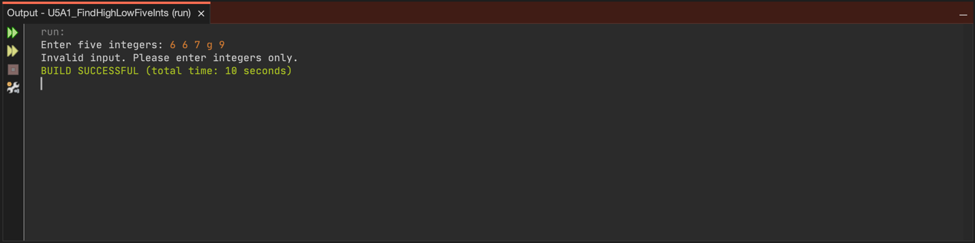
Passing Test
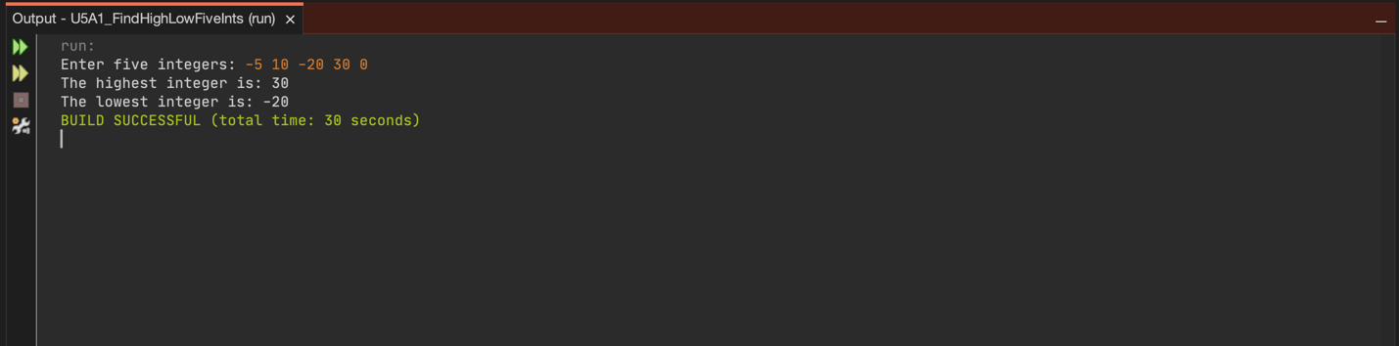
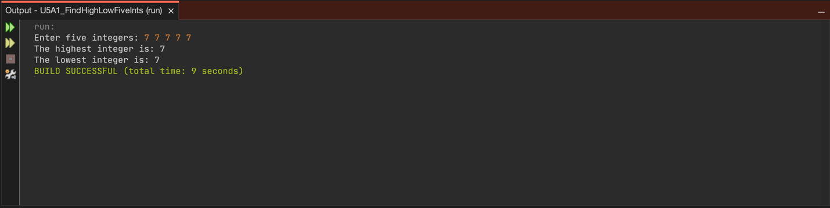

Explanation
Bugs Identified and Fixed
This project was not hard at all compared to previous assignments. The logic was straightforward and easy to implement. The main enhancement I made was adding a try catch block to handle exceptions. I imported InputMismatchException to catch cases where users enter non-integer values like letters or special characters, preventing crashes and improving program robustness. The try catch finally structure ensures the Scanner object is properly closed regardless of whether an exception occurs.
Approach and Testing
I began by carefully reading the assignment requirements to understand what was needed: accept five integers as input, determine the highest and lowest values using loops, and display the results. I wrote pseudocode first to outline the logical steps before implementing the actual code.
The development process was relatively simple. I created a Scanner object to read user input, then read the first integer and used it to initialize both the highest and lowest variables. This approach ensured I had starting values for comparison. I then used a for loop to read the remaining four integers, comparing each one against the current highest and lowest values and updating them as needed.
My testing strategy included several scenarios:
Test 1: Mixed positive and negative integers (such as the values 5, 10, 20, 30, 0) to verify the program correctly identifies both the highest and lowest values across different ranges.
Test 2: Five identical integers (7, 7, 7, 7, 7) to confirm the program handles edge cases where all values are the same.
Test 3: Invalid input containing a letter (6, 6, 7, g, 9) to test the exception handling and ensure the program provides appropriate error messages instead of crashing.
Each test confirmed that the program works correctly. The exception handling proved valuable during Test 3, where entering a letter triggered the InputMismatchException and displayed the error message I created.
Programming Constructs Used
This program demonstrates several important Java programming concepts:
Scanner class: The program uses Scanner to read user input from the console, utilizing the nextInt() method to capture integer values.
Variables and data types: Integer variables (number, highest, lowest) store the input values and track the maximum and minimum values found.
For loop: A for loop efficiently reads the remaining four integers after the first one is captured. The loop iterates exactly four times (i = 1 to i < 5), demonstrating precise loop control.
Conditional statements: If statements compare each new integer against the current highest and lowest values, updating them when appropriate conditions are met.
Exception handling: The try catch finally block structure manages InputMismatchException errors, providing user friendly error messages and ensuring proper resource cleanup.
String formatting: The printf() method with format specifiers (%d for integers, %n for newlines) creates clean, formatted output messages.
Comments and documentation: Inline comments and JavaDoc style documentation explain the program's purpose and logic, making the code maintainable and easy to understand.
Reflection
This assignment reinforced my understanding of Java loops and how they can simplify repetitive tasks. Using a for loop to process multiple inputs was much more efficient than writing separate code for each integer. The decision to initialize both highest and lowest with the first integer value was key to avoiding comparison issues.
Adding exception handling was a valuable learning experience. I learned how try catch blocks protect programs from crashes caused by unexpected user input. The final block ensured that system resources are always properly released, which is an important programming practice.
Testing the program with edge cases like identical values and invalid input helped me verify that the program behaves correctly under different scenarios. This systematic testing approach gave me confidence that the program meets all requirements.
Overall, this project was straightforward and helped me practice fundamental programming constructs like loops, conditionals, exception handling, and input validation. The experience of building a robust program that handles both valid and invalid input will be useful in future assignments and real world programming situations.

